**HEALTHCARE MANAGEMENT SYSTEM**

### Dissertation

Submitted in partial fulfillment of the requirements

For the degree of

### BE (Computer Engineering)

by

##### DOMINGOS FERNANDES (Roll No. 16CO56)

##### SARGAM NAIK DESSAI (Roll No. 16CO26)

##### ADITYA SAVAL(Roll No. 16CO39)

##### SEJAL SINGH (Roll No. 16CO60)

### GUIDE: PROF. NORA NAIK

### CO-GUIDE: PROF. POOJA DALVI



**Department of Computer Engineering**

**Agnel Institute of Technology and Design**

**Assagao, Bardez-Goa**

**Goa University**

**(2019-2020)**

**Approval Sheet**

This is to certify that **Mr. Domingos Fernandes**, bearing Roll no. 16CO56, **Mr. Sargam Naik Dessai,** bearing Roll no. 16CO26, **Mr. Aditya Saval,** bearing Roll no. 16CO39, and **Ms. Sejal Singh**, bearing Roll no. 16CO60, have been admitted to the candidacy of degree (Computer Engineering) in 2016-2020 and he/she has undertaken the thesis / dissertation entitled “**Healthcare Management System”** which is approved for the degree of BE (Computer Engineering) under Goa University as it is found satisfactory.

**Guide Co-Guide**

**Name: Prof. Nora Naik Name: Prof. Pooja Dalvi**

**Signature: _______________ Signature: _______________**

**Internal Examiner External Examiner**

**Name: ___________________ Name: ___________________**

**Signature: _______________ Signature: _______________**

**____________________________**

**Prof. Snehal Bhogan**

**Head of Department**

**Department of Computer Engineering**

**Date: _____________**

**Place: _____________**

**Dedication Sheet**

***This thesis is dedicated to our parents***

**Abstract**

Mobile applications are widely being used for a variety of services - Providing medical services through this technique can help save lives on time, unlike the current scenario wherein patients suffer due to untimely intake of medication, lack of availability of required blood group and unreliable ambulance services. The Application provides a solution to the above mentioned problem statements, in a unique way by integrating all the solutions in one single domain of Healthcare Management. The Healthcare management system will be easy to operate, and could be used by any common person, without having any technical knowledge. The aim of the Healthcare Management System will be to provide an easy, efficient and reliable portfolio system which will serve as an intermediate layer of interaction between the patient and the doctors and will be stored in a database of all the medical interactions using the LZMA compression algorithm, in order to simplify the task of doctors, as well as help the patients to easily access the services provided by the app. The app will remind the patient to take medicines on time, by sending alerts and reminders to the patient from time to time. The medical history of a patient will be stored in the server, in a compressed format and will be accessible to the medical staff, as well as the patient, as and when required. Doctor availability will be available in the software, to check if the best doctor, in a particular field, is available to the patient at a particular time. The ambulances will use trackers, and the patient will be aware of the nearest ambulances in and around his/her area, and could contact it in case of emergencies. The software will also provide the shortest route to the ambulance, from its current location, to the patient’s location. The software will also ensure to send a notification to blood donors, who have registered their names to donate blood to a patient of compatible blood group. This will help the patient to get the required blood group easily on time. Integrating all these features in one software, this will consist of our full fledged Healthcare Management System.

# Contents

|  |  |  |
| --- | --- | --- |
|  | Title | **Page No.** |
|  |  |  |
|  | List of Abbreviations | **7** |
|  | **List of Figures** | **8** |
| **Chapter 1** | Introduction | **9 – 13** |
| 1.1 | Overview | 9 |
| 1.2 | Application | 10 |
| 1.3 | Scope of Health Care Management | 11 |
| 1.4 | Project Objectives | 11 |
| 1.5 | Software and Hardware requirement | 12 |
| 1.6 | Organization of the Report | 13 |
| **Chapter 2** | **Literature Survey** | **14 – 16** |
| 2.1 | Who Uses Mobile Phone Health Apps and Does Use Matter? A Secondary Data Analytics Approach | 14 |
| 2.2 | Prevalence of medication adherence and its associated factors among patients with noncommunicable disease | 14 - 15 |
| 2.3 | Benefits of Management Information System in Blood Bank | 15 |
| 2.4 | Ambulance Service | 15 – 16 |
| 2.5 | A Brief Study of Data Compression Algorithms | 16 |
| **Chapter 3** | **Motivation and Significance of Work** | **17 - 18** |
| **Chapter 4** | Pre-Requisites | **19 – 27** |
| 4.1 | Definitions and Notations | 19 - 20 |
| 4.2 | Algorithms | 20 – 22 |
| 4.3 | Detailed working of the algorithm | 23 - 27 |
|  |  |  |
| **Chapter 5** | Proposed Work | **28 - 31** |
| 5.1 | Problem Definition | 28 |
| 5.2 | Project Specification | 29 - 31 |
| **Chapter 6** | Design | **32 - 37** |
| 6.1 | Patient Compliance Module | 32 |
| 6.2 | Ambulance Service Module | 32 |
| 6.3 | Blood Bank Service Module | 32 |
| 6.4 | Doctor Appointment Module | 33 |
| 6.5 | Patient Portfolio Management Module | 33 |
| 6.6 | Sequence Diagrams | 34 - 36 |
| 6.7 | Design Layout | 36 - 37 |
| **Chapter 7** | **Experimental Results** | **38 - 39** |
| 7.1 | Comparing LZMA and BZIP2 on Linux | 38 - 39 |
| **Chapter 8** | Conclusion | **40** |
|  |  |  |
|  | References | **41** |
|  |  |  |
|  | Acknowledgement | **42** |

**List of Abbreviations**

|  |  |
| --- | --- |
| API | Application Programming Interface |
| CI | Confidence Interval |
| EOF | End of FIle |
| GPS | Global Positioning System |
| ID | Identification |
| IDE | Integrated Development Environment |
| JDK | Java Development Kit |
| LZMA | Lempel-Ziv-Markov chain Algorithm |
| NCD | Non-Communicable Diseases |
| PR | Prevalence Ratio |
| RAM | Random Access Memory |
| REST | Representational State Transfer |

**List of Figures**

|  |  |  |
| --- | --- | --- |
| **Figure No.** | **Title** | **Page No.** |
| 4.01 | LZMA algorithm flowchart | 20 |
| 4.02 | Character-Value Mapping | 23 |
| 4.03 | Delta Decoding on input stream | 23 |
| 4.04 | Sliding Dictionary Encoding | 23 |
| 4.05 | Calculated Distribution | 24 |
| 4.06 | Determining string value | 24 |
| 4.07 | Determining string Value | 24 |
| 4.08 | Final string value range | 25 |
| 4.09 | Obtaining string from given value | 25 |
| 4.10 | Final string from given value | 26 |
| 4.11 | Sliding dictionary decoding | 26 |
| 4.12 | Delta decoding to obtain original data | 27 |
| 6.01 | Sequence diagram for Patient Compliance | 34 |
| 6.02 | Sequence diagram for Patient Portfolio | 34 |
| 6.03 | Sequence diagram for Blood Bank System | 35 |
| 6.04 | Sequence diagram for Doctor Appointment | 35 |
| 6.05 | Sequence diagram for Ambulance Service | 36 |
| 6.06 | Design Layout of Mobile Application | 36 |
| 6.07 | Design Layout of Mobile Application | 37 |
| 6.08 | Design Layout of Mobile Application | 37 |
| 7.1 | Compressing files using LZMA | 38 |
| 7.2 | Files combined using rar archive followed by compression using BZIP2 | 39 |

**Chapter 1**

**Introduction**

* 1. **Overview**

Healthcare management systems are usually designed for healthcare providers working in hospitals to gather , maintain and exchange patient information regarding his/her health efficiently, and provide better patient healthcare to all the patients and other users. It has facilities to provide better service to patients and access their medical information easily on the go.

‘Health care’ and ‘medical care’ both seem to be synonymous. The term ‘medical care’ can be said to be a subset of the healthcare system.‘Medical care’ ranges from the place where the patient lives to the hospital where the care was provided to the patient and it refers mainly to the services provided directly by physicians and doctors of the hospital or the instructions rendered by them.

The health of society as a whole is characterised by how accessible and affordable the quality of service is provided by any healthcare services. The best health services should be easily accessible, both when time as well as distance is taken into consideration for all classes of society, that can be afforded by the society. The government providing these facilities which are affordable by the common people who utilise them, of a minimal acceptable standard to keep up with the needs of the users at each level, accessible to all classes of society who require them and which part of the range in their coverage, with effective utilisation and distribution of available resources.

* 1. **Application**

The E-prescription system of the healthcare management system will allow the doctors to upload the medicines names prescribed and the time to consume them, on the server through the web app, and then the mobile application installed on the user’s mobile will remind the patient to consume the prescribed medicines on time written on the prescriptions by the doctor. Alerts on Medicine Intake timing is via notifications, messages and calls to confirm, whether the medication has been consumed by the patient.

To check the doctor availability the patient Selects department/doctor name and the list of doctors with contact information/doctor availability will be displayed on the mobile application of user’s device. The Receptionist enters the Doctor name, specialization and timings in the database and the list of Doctors recorded and stored in a particular database available on a given day will be displayed.

To use the ambulance locator feature the user starts the application and enables GPS and calls for an ambulance. The ambulance that is free and coming is displayed.The hospital Accepts the request and The location of the user is displayed with the shortest path.

The user needs to enter the Blood Type, Name of patient, Age, Contact, Gender and clicks on ALERT, this will provide the information whether the blood type is available in the bank ,if not then the contacts of people with blood group will be displayed. The people who are willing to donate their blood can register their names and provide their phone number, blood type, gender, height, weight and other required information, so that they can be contacted during the time of emergency.

The details of the patient - Name, contact no, medical case history, date and time and other information given will be uploaded by the medical staff. The information will be stored in the database of the hospital. Patient can access his/her own medical history, by logging into his private account in the app, and can view it whenever required. Portfolio and Medical history displayed on the mobile application downloaded on the user’s mobile.

* 1. **Scope of Healthcare Management System**

The scope of this project is to develop a healthcare management system having features like E-prescription, Ambulance locator, Management of patient portfolio, Availability of doctors, and Blood bank info. The project aims at improving patient compliance and find a smarter way to deal with problems existing in the current hospital management system. To implement the system in order to provide improvised and better healthcare services to patients and also make the documentation and other information handling hassle free for the hospital staff and doctors. This will help to deal with hospital formalities in more secure and smarter way.

* 1. **Project Objective**

The work presented here aims at the following aspects.

* To improve patient compliance using e-prescription service.
* To provide easy access to the patient portfolio and keeping its storage more secure and smart.
* To eliminate the chaotic situation when there is an urgent requirement for particular blood types during emergency situations. Making it more systematic and for donors as well as users.
* To track ambulance and check for the availability of doctors in a hospital on a particular day.

* 1. **Software and Hardware Requirements**
     1. **Software Requirements**
* Windows 7/8/10
* Java SE Development Kit 7(JDK 7)
* NetBeans IDE
  + 1. **Hardware Requirements**
* Intel Core i3 processor
* 2 GB RAM

* 1. **Organization of the Report**

The report is organized in 8 chapters in total.

* Chapter 2 covers the Indian Healthcare Survey, which explains various reasons why the world lacks in timely medical facilities.
* Chapter 3 states the Motivation and Significance of work in medicine
* Chapter 4 deals with the pre-requisites. The required definitions, algorithms, formulas and tools are explained in this chapter.
* Chapter 5 states the proposed work with the problem definition and project specification.
* Chapter 6 explains the detailed design methodology to achieve the objectives.
* Chapter 7 shows the implementation of compression algorithms and obtained results on different types of files
* Chapter 8 states the conclusion analyzing the project.

**Chapter 2**

**Literature Survey**

* 1. **Who Uses Mobile Phone Health Apps and Does Use Matter? A Secondary Data Analytics Approach**

Jennifer Carroll , Anne Moorhead, Raymond Bond, William G. LeBlanc,Robert J. Petrella and Kevin Fiscella conducted a study to identify the users of healthcare mobile applications based on their social demographic and health characteristics, intentions to change and actual health behavior.

Data on the users of mobile health applications were analyzed from the National Cancer Institute's 2015 Health Information National Trends Survey (HINTS) which was conducted in the United States. The results showed that the main users of mobile health applications were individuals who were younger,had more education, reported being in good health and had a higher income - application use was associated with intentions to change the diet and physical activity and meeting physical activity recommendations.

It was also found that many people were not using health apps due to old age and not being educated about the benefits of having a mobile health application.

* 1. **Prevalence of medication adherence and its associated factors among patients with noncommunicable disease**

A facility-based cross-sectional study was done among 260 patients with NCD receiving treatment from rural primary health center in Pondicherry during February and March 2018. Information regarding sociodemographic profile and household was collected using pretested semi-structured questionnaire. Morisky Medication Adherence Scale was done to assess the adherence. They calculated adjusted prevalence ratios (which is the ratio of people affected with a disease divided by the number of people in exposure to the disease) to determine the factors associated with medication adherence.

Among the 260 participants, 111 were in elderly age category; 173% were females; 115 did not have any formal education; 182 were unemployed. A large number were suffering from High Blood Pressure (201) followed by diabetes (147). The study conducted found that almost one-third (85) of the study participants were not properly adherent to medications. Elderlyand female participants were found to be more probable of being non adherent to medications after adjusting for possible confounding variables. Corrective measures need to be started at patient level regarding the importance of drug intake.

* 1. **Benefits of Management Information System in Blood Bank**

Vikas Kulshreshtha and Dr. Sharad Maheshwasri discuss in their paper about the many benefits of implementing a management information system in a blood bank

such that users can find out about the availability of blood in the blood bank or find out where blood donation camps are will be taking place in their local area. It is also highly beneficial to the blood bank as they can notify people who have donated previously incase of an emergency and blood not being available in the blood bank or to generate a report on a regular basis about the amount of blood donated or amount of blood discarded and the reason for discarding.

* 1. **Ambulance Service**

Smart Ambulance System Emergency response in the medical sector in India lacks the essential features and hence India lags behind other countries. The reason is at ground zero, partially due to lack of implementation of technology. To address the issue, smart ambulance system has been introduced. India will be at a competitive position around the globe in emergency services. Seamless use of applications can be done & subset of a huge data amount is processed and accessed powerfully and easily widely in large number of end systems. Smartphone technologies builds a platform serving all types of smartphone users. The application makes use of GPS hardware to collect location information and Google Map API plots the details of ambulances on the Smartphone App via Google Map Client. Similar functionality is used for rest of the modules enabling users to find the number of services provided by hospitals in a brief manner. Information regarding health details of the patient is sent to the hospital to take further action. Interaction between centralized database and smartphones is done using REST APIs with the help of technologically powered medically equipped ambulances. Platforms capable of shaping services of different types are implemented and it is believed that these technologies if utilized properly, can make a difference in public GPS work.

* 1. **A Brief Study of Data Compression Algorithms**

Yogesh Rathore,Manish k. Ahirwar and Rajeev Pandey conducted a study of various data compression algorithms.Tests were carried out between LZMA, LZMA 2 Burrows-Wheeler Transform(bzip) , Adaptive Lempel-Ziv coding, in deflate mode (gzip) , ZIP and RAR.

It was found that LZMA has a higher compression ratio as compared to other compression algorithms but takes a longer time for compression of files. This is useful in patient portfolio management since there will be a large number of records that need to be stored. The time for compression will be longer than other compression algorithms but will not affect a system in any way.

**Chapter 3**

**Motivation and significance of work**

**A healthcare management system is something much more than a regular IT project.**

Implementing an infrastructure based on new technology and digitizing the clinical and patient information are said to be only part of the process of proceeding to a full fledged healthcare management system. There is also an important component known as “people component.”

Medical professionals using the system on a daily basis such as physicians, doctors and medical staff such as medical receptionists, technicians, and many others need are required to be engaged early on in the process so that they have a say as to how the system is designed, to receive appropriate training, and hence have an ample amount of time to prepare for what will be a significant shift in how they work.

This requires that providers focus on change management from the outset of their healthcare management system project.

Many providers decide to seek outer assistance to help ensure an easy transition to a healthcare management system. For instance, they refer to project staffing services which provides consultants with business systems expertise and healthcare management.

**Significance**

In the current world scenario, people find it hard to maintain their health, due to their busy work lifestyle. Simplifying healthcare systems by means of features provided by our project, health of any particular person can be taken care of, in much simplified ways.

Healthcare software solutions have become such an important integral part of modern hospitals and clinical facilities. The days of paper-based files and written patient records have rapidly given way to touch screens, tablets and online reports. All of this has been possible with the giant strides we have taken in the fields of information and technology.

Even though our world has progressed significantly in the past few years, timely health care management hasn’t sufficed, being the cause for loss of human lives.

Therefore, our project signifies the delivery of a full fledged healthcare management for the benefit and welfare of society.

**Chapter 4**

**Pre-Requisites**

* 1. **Definitions and Notations**
     1. **Adherence**

In medicine, patient compliance describes the degree to which a patient correctly follows medical advice. It refers to drug compliance or medication, but can also be applied to situations such as self-directed exercises, self care, medical device use, and or therapy sessions

* + 1. **Data Compression**

Data Compression is the science and art of representing data in a compact format, wherein a reduction in the number of bits is needed to represent the data and hence is a solution to problems like high cost and restricted space. .

* + 1. **Range Encoding**

**Range encoding** is also an entropy coding method defined by G. Nigel N. Martin in 1979 Considering the probabilities of an input stream, a range coder represents this data by producing a space-efficient stream of bits and given the probabilities of the stream, the range decoder obtains the original input stream.

* + 1. **Dictionary Compression**

A **dictionary coder**, also known as the **substitution coder**, operates by searching for matches between the text being compressed and a set of strings contained in a dictionary or the data structure which is maintained by the encoder. When a match is found by the encoder, a reference to the string's position in the data structure is substituted. Hence it is a type of lossless data compression algorithms.

* 1. **Algorithms**

**4.2.1 LZMA Compression Algorithm**

The Lempel-Ziv-Markov chain Algorithm (LZMA) is an algorithm that performs lossless data compression. It uses a dictionary scheme that is similar to LZ77 and features a high compression ratio. The diagram below shows the stages involved in compression and decompression of the data.

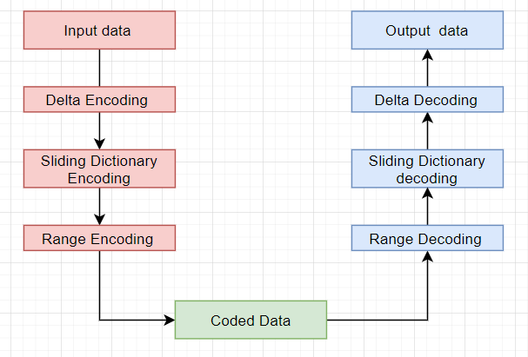

*Figure 4.01* : LZMA algorithm flowchart

**4.2.2 Compression Algorithm Details**

**4.2.2.1 Delta Encoding (Optional - results in higher compression)**

**1)** Consider first byte of Input data stream

**2)**  Until End-Of-File(EOF) Marker is not encountered

2.1) Read next byte of input data stream

2.2) find difference between the read byte and previous byte and store it

2.3) Goto step 2

**3)** Delta encoding output is passed to Sliding Dictionary encoding.

**4.2.2.2) Sliding Dictionary Encoding**

Sliding windows are split into 2 parts : Dictionary buffer and lookahead buffer

* Dictionary buffer is a buffer of L1 positions

it holds the L1 most recently encoded symbols from the input

* lookahead buffer is a buffer of L2 positions

it holds the L2 symbols about to be encoded

**Algorithm**

Dictionary buffer = L1 copies of symbols from 1st symbol of input

In each iteration until end of input stream

1. Search dictionary buffer for substring matching a prefix of substring located in look-ahead buffer.
2. If match is found codeword is triple <p,l,s>

where p = position p in which the match is found

l = length of the match

s = first mismatching symbol following the prefix

1. Shift the entire content of the buffer (dictionary buffer and look-ahead buffer) by length and plus one (some symbols are shifted out and some new symbols from the input are shifted in)

**4.2.2.3)Range Encoding (Adaptive binary range encoder)**

1. Compute probabilities for each unique byte in output of sliding dictionary encoding step
2. Compute the range value for the next symbol in input
3. If range value becomes too large perform normalization and append the normalised component to the end or compressed data
4. repeat step 2 and 3 until end of the stream

**4.2.3 Decompression Algorithm Details**

**4.2.3.1) Range Decoding**

1. Based on range and distribution probability identify the string that corresponds to the input
2. shift range to improve precision
3. if range is too small perform normalisation
4. Repeat until End of File marker is obtained.

**4.2.3.2) Sliding Dictionary Decoding**

1. To decode a stream of triples, the decoder first initializes the dictionary buffer with the first received symbol
2. In each iteration until the end of triples

for each triple <p,l,s>

starting from position p, copy l symbols to the lookahead buffer and add the symbols at the end of the copied string

output = copied substring along with the symbol ‘s’ i.e. decoded symbol.

**4.2.3.3) Delta Decoding**

1) Consider first byte of data stream input and set it to variable i

2) While Input is not empty

2.1) Read next byte of input data stream

2.2) find sum between byte and i and store it

2.3) Set i to next byte that was read

2.4) goto step 2

3) Delta decoding output is the decompressed text.

**4.3 Detailed working of the algorithm**

**4.3.1) Compression Phase**

1. Delta encoding

* Assumed mapping for example

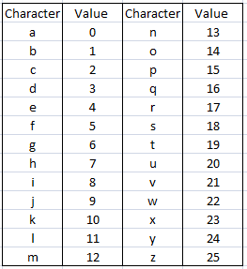

*Figure 4.02 : Character-Value mapping*

* Input stream considered as values

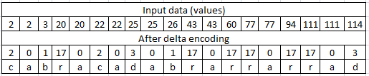

*Figure 4.03 : Delta decoding on input stream*

1. Sliding dictionary encoding

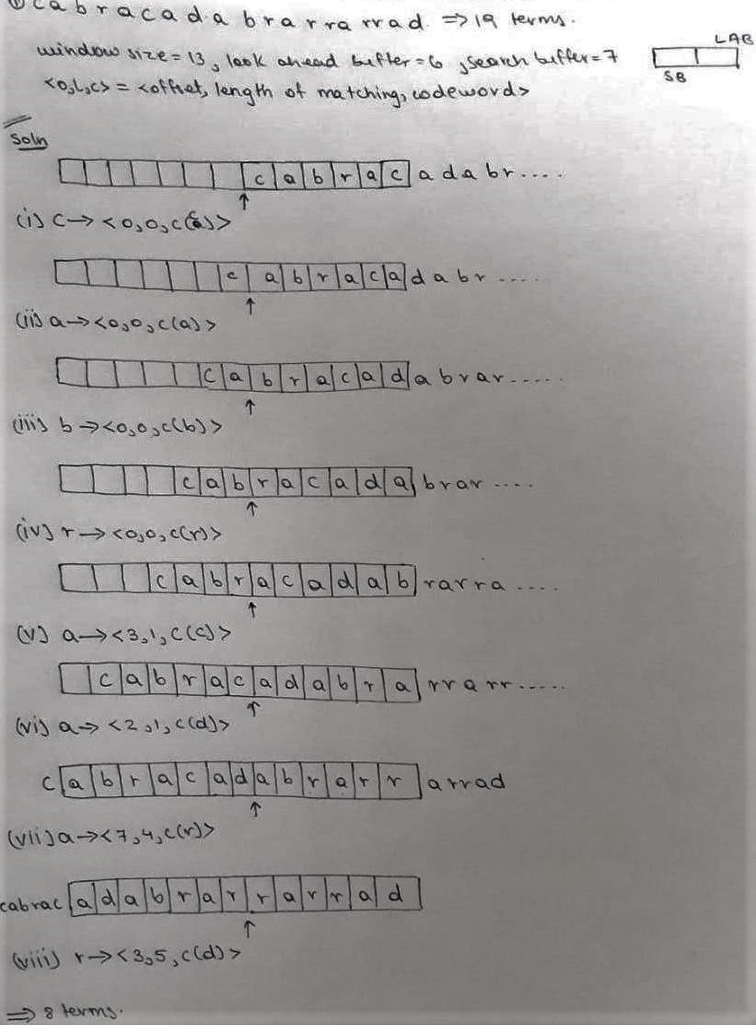

*Figure 4.04 : Sliding dictionary encoding*

1. Adaptive range encoder

* Calculate distribution



*Figure 4.05 : Calculated distribution*

* Determine value

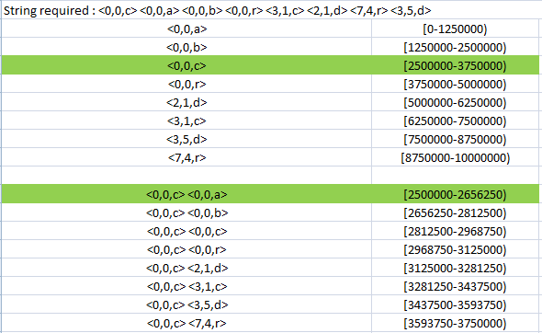

*Figure 4.06 : Determining string value*

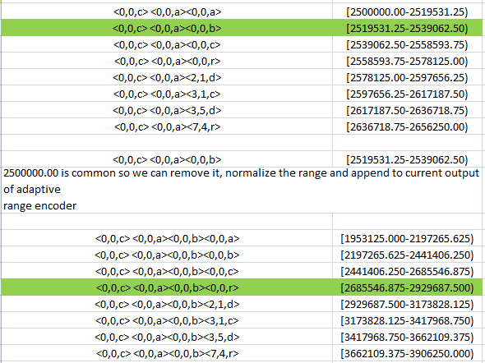

*Figure 4.07 : Determining string value*

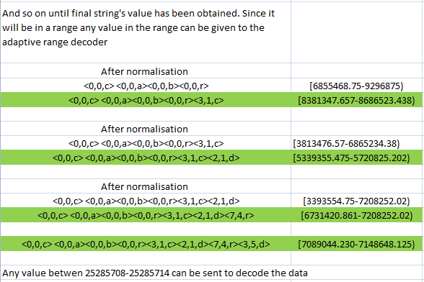

*Figure 4.08 : Final string value range*

**4.3.2) Decompression Phase**

1. Adaptive range decoder

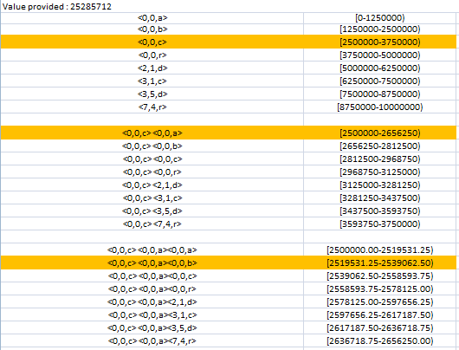

*Figure 4.09 : Obtaining string from given value*

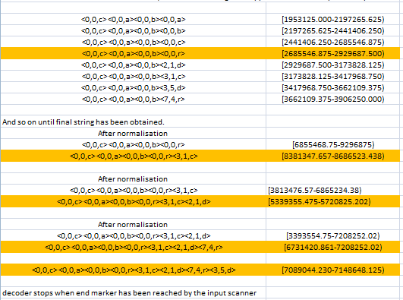

*Figure 4.10 : Final string from given value*

1. Sliding dictionary decoding

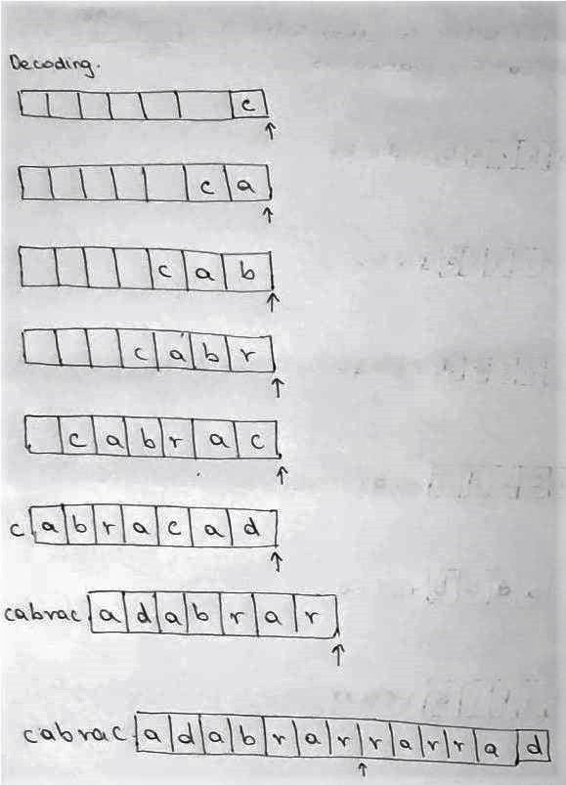

*Figure 4.11 : Sliding dictionary decoding*

1. Delta decoding

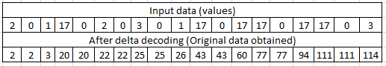

*Figure 4.12 : Delta decoding to obtain original data*

**Chapter 5**

**Proposed Work**

* 1. **Problem Definition**

The healthcare management system is implemented to improve several processes in the healthcare sector. Previously a lot of problems were faced,some of these problems include

1) Prescriptions are written on paper and timely intake of medication lies completely on the patient. Relatives of the patient may also provide assistance but in most cases, and not at all times.

2)Documents are not stored in an organized manner which can be accessed easily later

3)Incase of blood requirements - relatives have to ask on social media or their relatives

4)Patients don’t know which doctor to go to or which doctor is currently available

5) The current state system of ambulance services relies on calling the nearest ambulances and checking if they can respond to the casualty

The consequences of the above stated problems could result in loss of life , The aim of our application is to improve the healthcare treatment,advice and facilities thereby solving the problems and simplifying the entire process .

* 1. **Project Specification**

**E-Prescription**  -

Hospital(doctor) on the web app

Input: Doctor will enter the name of the medicine in the list, the number of

times the patient should take the medicine, and the time of intake.

Output: E-Prescription in the database

Received by the patient on the mobile app

Input: Patient starts the application which checks for prescription on server

Output: E-Prescription will be received by the Patient on the mobile application, which could be shown in pharmacy to obtain medicines, Alerts on Medicine Intake timing through the form of notifications, messages and calls to confirm, whether the medication has been consumed by the patient.

**Medical History**

Hospital(medical staff on the web app) :-

Input: The details of the patient - UID(Aadhar No.), name, contact no,

medical case history,date and time given as input by the medical staff.

Output : The database stores the information.

User :-

Input : Patient can access his/her own medical history, by logging into

his/her account in the app, and can view it whenever required.

**Blood Donation**

User :-

Input: Enters the Blood Type, Name of patient, Age,

Contact and clicks on ALERT

Output : Receives either availability of blood in bank

or contacts of people with blood group

Hospital :-

Input : When blood is not available for certain type

Output : Sends notification to users with same blood group

Output: Portfolio and Medical history displayed.

**Doctor Availability**

User :-

Performed by the hospital(medical staff) on the web app

Input - Selects department/doctor name

Output - Displays list of doctors with contact information/doctor availability

Hospital :-

Input: The Receptionist enters the Doctor name, specialization and timings in the database.

Output: List of Doctors records are stored in the database available on a particular day

**Ambulance Locator**

User :-

Input - Starts the application and enables GPS and calls for ambulance

Output - The ambulance that is free and coming is displayed

Ambulance :-

Input - Accepts the request

Output - The location of the user is displayed with the shortest path

**Purpose**

The purpose is to describe all the requirements for Hospital Management System. The following are a few of the stakeholders:

• Administrative staff

• Doctors

• Nurses

• Patients

**Scope**

The software product is the Healthcare Management System. Regarding the scope of the Healthcare Management System, it will be to provide an easy, efficient and reliable system which will serve as an interface between patients and doctors and will be stored in database using the LZMA compression algorithm, in order to simplify the task of doctors.

The feature of the Healthcare Management System will include the following:

1) The timely consumption of medicines

2) Doctor availability at a particular time

3) Nearby ambulance Locator

4) Blood Donor Finder

5) Patient portfolio management

**Chapter 6**

**Design**

* 1. **Patient Compliance Module**

1. After consultation, the doctor prescribes medicine to the patient, using the E-Prescription service, through his/her Web app.
2. This in turn, stores the prescription medicine details in the database.
3. The patient has access to the database through his/her account created on the mobile app, which can be accessed anytime and anywhere.
4. Another feature of this module comprises reminders for the timely consumption of medicines by the patient.
   1. **Ambulance Service Module**
5. Incase of medical emergency a user will have to start the app with GPS enabled on his/her device
6. The application contacts a server that keeps track of all the ambulances in the area and their proximity to the casualty - It determines based on severity, no of victims and position the most suitable ambulance that can arrive and send a message to the driver’s app to arrive with ambulance

**6.3 Blood Bank Service Module**

1. A unique ID is created for each patient donating blood
2. The blood type,unique ID and other essential information is stored by the blood bank
3. The hospital will have a means to update a database that records the amount of blood available and users can use the app to check if blood is available
4. Incase a specific blood group is not available, a notification is sent to all the people who have donated blood and the person in need can directly contact them and check if the donors are willing for blood donation.

**6.4 Doctor Appointment Module**

1. The attendance list of Doctors for the particular day is uploaded by the medical staff to the Server List via the Web App.
2. The patient logs in through his web app and chooses the Doctor availability option.
3. The list is displayed on the database, and can be accessed by the patient to view the availability of doctors.

**6.5 Patient Portfolio Management Module**

1. A unique ID (Phone.no) is created for each patient in the hospital
2. The ID along with the file associated for the patient is stored in fact tables in a database
3. Patients who log in with the app will be able to download the file and see the reports/scans at any time
4. Files will be deleted after a month inorder to prevent storage from getting full

**6.6 Sequence Diagrams**

1. E-Prescription

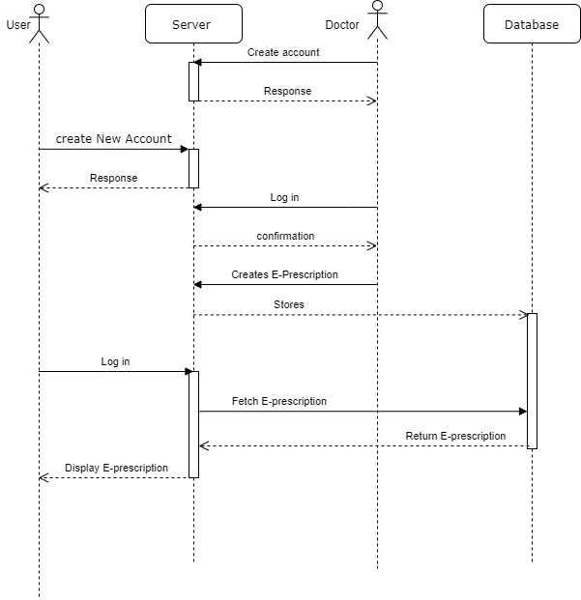

*Figure 6.01 : Sequence diagram for Patient Compliance*

1. Patient Portfolio

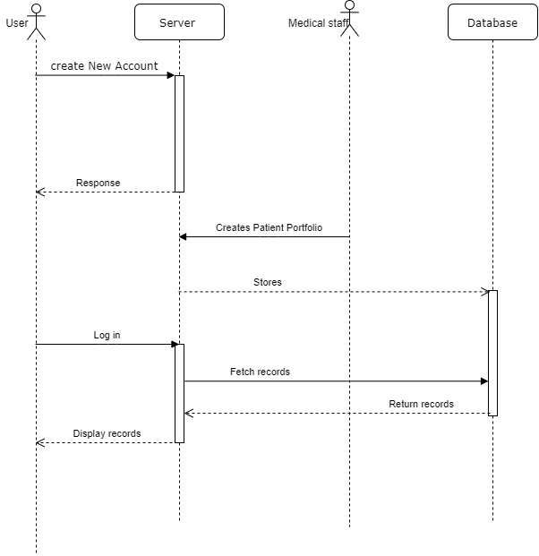

*Figure 6.02 : Sequence diagram for Patient Portfolio*

1. Blood Donation

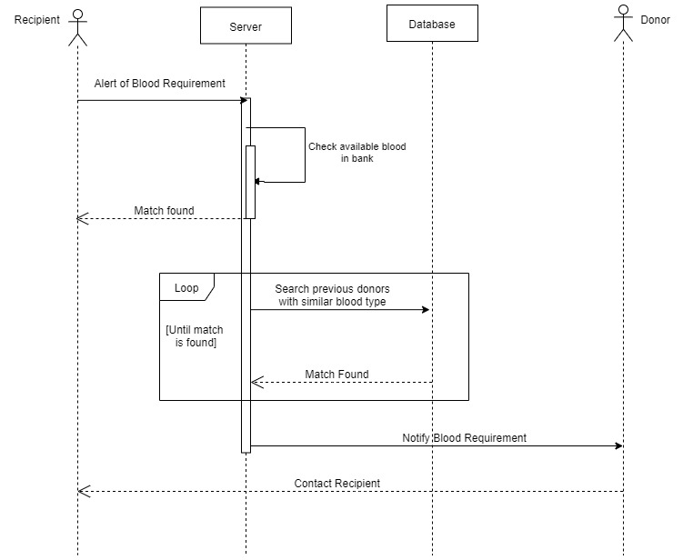

*Figure 6.03 : Sequence diagram for Blood Bank System*

1. Doctor Appointment

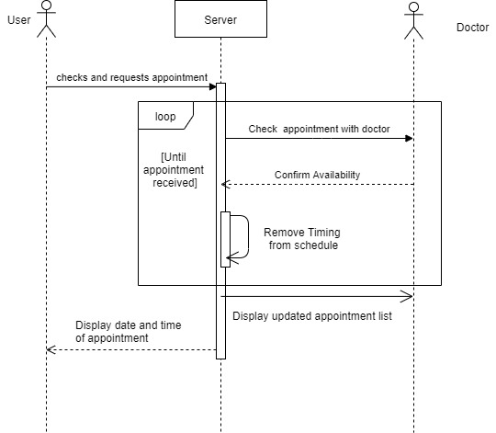

*Figure 6.04 : Sequence diagram for Doctor Appointment*

1. Ambulance Locator

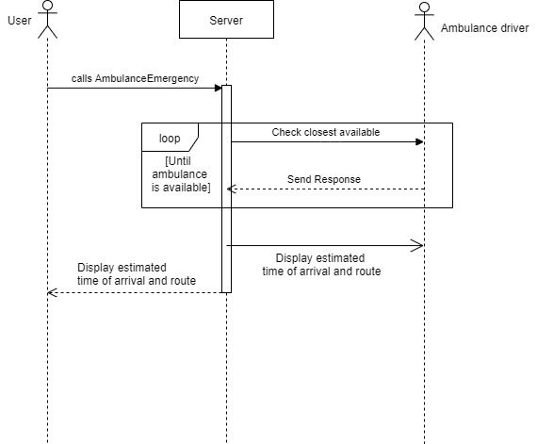

*Figure 6.05 : Sequence diagram for Ambulance Service*

**6.7 Design Layout**

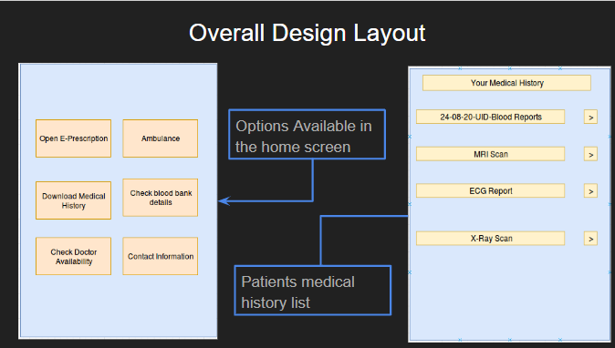

**`** *Figure 6.06 : Design Layout of Mobile Application*

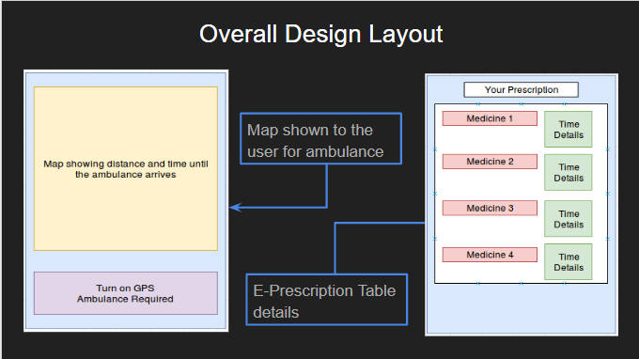

*Figure 6.07 : Design Layout of Mobile Application*

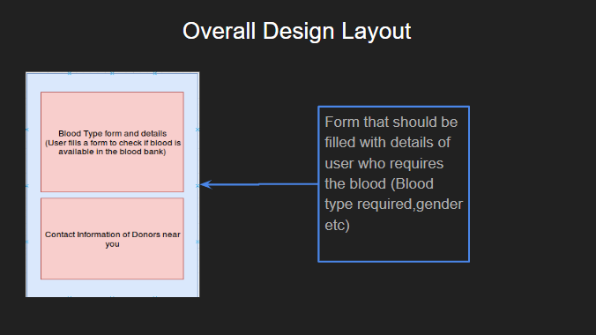

*Figure 6.08 : Design Layout of Mobile Application*

**Chapter 7**

**Experimental Results**

* 1. **Implementation Steps**
     1. **Comparing LZMA and BZIP2 on Linux**

Using the inbuilt utility in Linux , Files were compressed and the compression time as well as the size of the file was recorded. Note the files were compressed in normal mode (modes range from fastest compression to ultra compression)

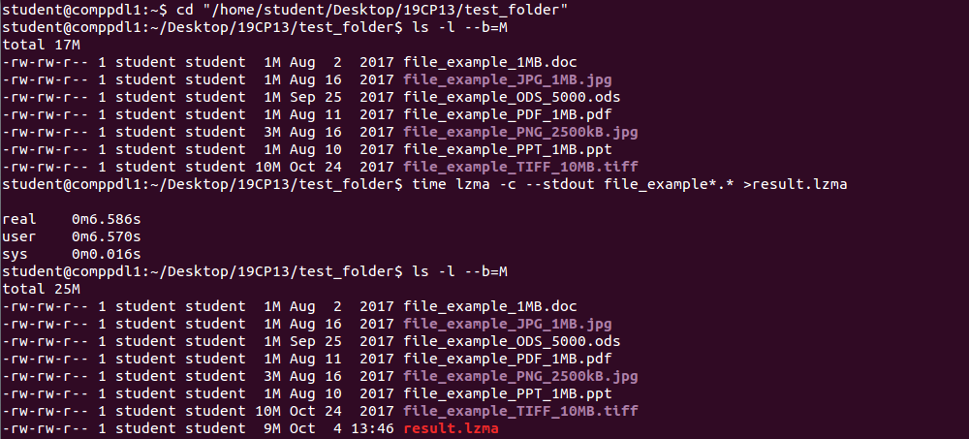

*Figure 7.1: Compressing files using LZMA*

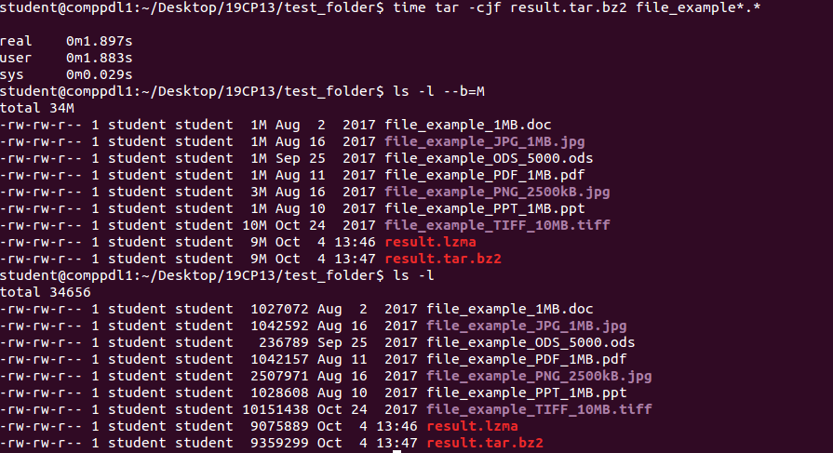

*Figure 7.2: Files combined using rar archive followed by compression using BZIP2*

As can be seen from the results the time taken by LZMA is higher than BZIP2 in compression but it results in higher compression ratio. (30KB is saved) This matters as the input scales as it means more space will be saved.

**Chapter 8**

**Conclusion**

The motivating insight on this research is that recognizing the notes manually becomes time-consuming and untidy process hence there is need of applications with which Healthcare Management process can be efficiently done. Using web development and mobile application techniques this process becomes more software oriented thus aiding a person to utilize medical facilities on time.

Considering all the mentioned details, we can conclude that the hospital management system of the modern medical institution is an inevitable part of its lifecycle. It enables smooth interactions of the users and automates various daily operations. Developing the healthcare system software is an opportunity to create a fast, distinct and efficient delivering healthcare model. Implementing the healthcare management system project helps implement policies, market hospital services, arrange the supply chain, storing all kinds of records, improve day-to-day operations, provide coordination and user communication, manage financial and human resources. This advantageous decision simplifies their interactions, covers the needs of the patients, and staff and hospital authorities. It is the usual approach of managing the hospital.

**References**

[1] “Prevalence of medication adherence and its associated factors among patients with noncommunicable disease in rural Puducherry, South India – A facility-based cross-sectional study” --Dr. K Yuvaraj,Department of Preventive and Social Medicine, Jawaharlal Institute of Postgraduate Medical Education and Research, Pondicherry   
India

[2] Shanmugasundaram, S. and Lourdusamy, R., 2011. “A comparative study of text compression algorithms”. *International Journal of Wisdom Based Computing*, *1*(3), pp.68-76.

[3] Berman, P., Ahuja, R. and Bhandari, L., 2010. “The impoverishing effect of healthcare payments in India: new methodology and findings”. *Economic and Political Weekly*, pp.65-71.

[4] Eraker, S.A., Kirscht, J.P. and Becker, M.H., 1984. “Understanding and improving patient compliance”. *Annals of internal medicine*, *100*(2), pp.258-268.

[5] Wadhwa, S., Wadhwa, P., Mirchandani, S. and Joseph, R., 2017, October. “Optimized rescue system for accidents and emergencies”. In *2017 2nd International Conference on Communication and Electronics Systems (ICCES)* (pp. 555-559). IEEE.

[6] Carroll JK, Moorhead A, Bond R, LeBlanc WG, Petrella RJ, Fiscella K “Who Uses Mobile Phone Health Apps and Does Use Matter? A Secondary Data Analytics Approach” J Med Internet Res 2017;19(4):e125

[7] Kulshreshtha, V. and Maheshwari, S., 2011. “Benefits of management information system in blood bank”. *dalam International Journal Of Engineering And Science. ISSN*, pp.2278-4721.

[8] Rathore Y.,Ahirwar M.k. and Panday R.,2013 “A Brief Study of Data Compression Algorithms”. *International Journal of Computer Science and Information Security, Vol. 11 No. 10 Oct 2013 (*pp. 86-94) Accessed at https://www.academia.edu/11814232/A_Brief_Study_of_Data_Compression_Algorithms

[9] Gupta P., Pol S.,Rahatekar D., Patil A.,2016 “Smart Ambulance System”,

*International Journal of Computer Applications (0975 – 8887)* Accessed at

https://pdfs.semanticscholar.org/6bd6/3a0a2f9473ad725c6ff72c5883b14e0123c9.pdf

**Acknowledgement**

We are greatly indebted to my guide Prof. Nora Naik, Faculty, Computer Engineering Department, Agnel Institute of Technology and Design, Goa for her valuable guidance throughout the dissertation, without which the study undertaken would not have been accomplished at all. My sincere thanks to my co-guide, Prof. Pooja Dalvi, Faculty, Department of Computer Engineering, Agnel Institute of Technology and Design, Goa for the constant support and encouragement rendered throughout the mission.

Our sincere thanks to our Head of Department Prof. Snehal Bhogan for the constant support and encouragement rendered throughout the project.